How to use a computer to program N series radios
1, Edit the red information below to your needs

comment code:
change the "your group name" that you needed
Change the "Your Test channel 16" for your channel name
If your device has more than 16 channels, please copy more channels and edit

rf=receive frequency, change the "409.8" to your needed
TF=transmit frequency ,change the "409.8" to your needed
The frequency range cannot exceed the frequency range allowed by the device

RS=Receive CTCSS/DCS,change the "8850" to your needed
TS=Transmit CTCSS/DCS,change the "8850" to your needed
8850 means 88.5HZ,18350 means 183.5HZ
74 means D74N,351 means D351N
If RS and TS are not required,, please delete "rs":8850,"ts":8850," this code.

p means output power
0 Hihg power
-2 mid power
-1 low power

2,Copy the red paragraph below that you have edited to your phone
Copy this text and start HT
{"n":"your group name","chs":[
{"n":"Your Test channel 1","rf":"409.8","tf":"409.8","rs":8850,"ts":8850,"id":1,"p":-1},
{"n":"Your Test channel 2","rf":"409.8","tf":"409.8","rs":8850,"ts":8850,"id":1,"p":-1},
{"n":"Your Test channel 3","rf":"409.8","tf":"409.8","rs":8850,"ts":8850,"id":1,"p":-1},
{"n":"Your Test channel 4","rf":"409.8","tf":"409.8","rs":8850,"ts":8850,"id":1,"p":-1},
{"n":"Your Test channel 5","rf":"409.8","tf":"409.8","rs":8850,"ts":8850,"id":1,"p":-1},
{"n":"Your Test channel 6","rf":"409.8","tf":"409.8","rs":8850,"ts":8850,"id":1,"p":-1},
{"n":"Your Test channel 7","rf":"409.8","tf":"409.8","rs":8850,"ts":8850,"id":1,"p":-1},
{"n":"Your Test channel 8","rf":"409.8","tf":"409.8","rs":8850,"ts":8850,"id":1,"p":-1},
{"n":"Your Test channel 9","rf":"409.8","tf":"409.8","rs":8850,"ts":8850,"id":1,"p":-1},
{"n":"Your Test channel 10","rf":"409.8","tf":"409.8","rs":8850,"ts":8850,"id":1,"p":-1},
{"n":"Your Test channel 11","rf":"409.8","tf":"409.8","rs":8850,"ts":8850,"id":1,"p":-1},
{"n":"Your Test channel 12","rf":"409.8","tf":"409.8","rs":8850,"ts":8850,"id":1,"p":-1},
{"n":"Your Test channel 13","rf":"409.8","tf":"409.8","rs":8850,"ts":8850,"id":1,"p":-1},
{"n":"Your Test channel 14","rf":"409.8","tf":"409.8","rs":8850,"ts":8850,"id":1,"p":-1},
{"n":"Your Test channel 15","rf":"409.8","tf":"409.8","rs":74,"ts":74,"id":1,"p":-1},
{"n":"Your Test channel 16","rf":"409.8","tf":"409.8","rs":18350,"ts":18350,"id":1,"p":0},
]}
3, Store it in the phone pasteboard

4,Open the “HT” app, The following page will be displayed.
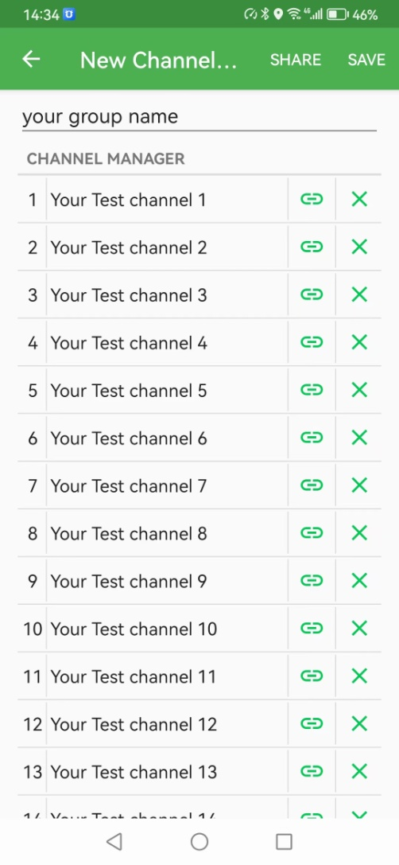
5,If radio connected, click save will be save to radio group,select the group that you wanted.
If radio disconnect ,click SAVE to save the data on app. When radio connected. Click Setting-channel group manager,click the arrow to save the group data sync to radio .
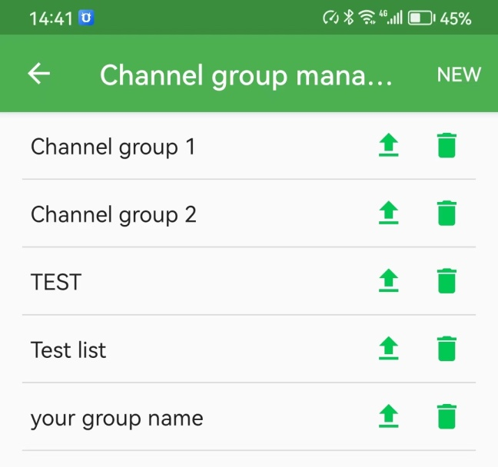
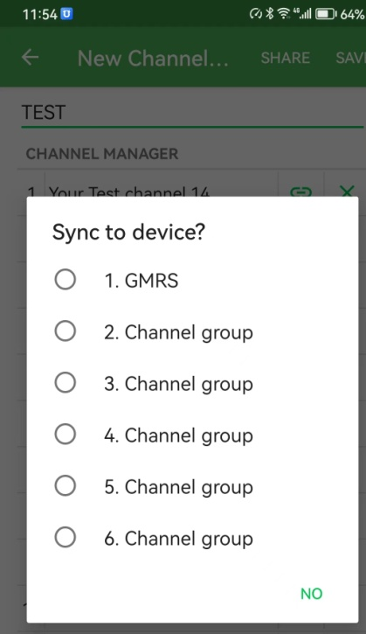

How to Program radios in Batches
1, Turn on all radios to be programmed, and switch the menu to Receive channels.
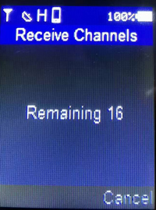
2, Turn on the programmed radio as a transmitter, and switch the menu to Send channels.
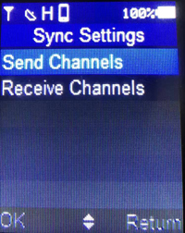
3,Data transmission is in progress, you can see the number of channels on the receiver changes, when the receiver screen shows completed, it means the transmission has been completed
